Hungry Birds

Food Bank & Free Store

Request for Proposal

Version 1.0

|  |  |  |  |
| --- | --- | --- | --- |
| Version | When | Who | What |
| 1.0 | 2017 Fall | Chris Zhao  Devroop Banerjee  Hongyu Dai  Tariq Chatur  Xuyao Qin  Wanjin Yoo | Initial Drafting |

**Table of Contents**

1.0 Problem description

2.0 Project Objectives

3.0 Current System(s) – if any or similar systems

4.0 Intended users and their interaction with the system

5.0 Known interactions with other systems inside/outside the client organization

6.0 Known constraints to development

7.0 Project Schedule

8.0 Client team

9.0 Glossary of terms

**1.0 Problem description**

The current UVSS food bank and free store lacks an online and paperless inventory management system. The efficiency of current managing system is too low. The food bank has a tight budget and any unaccounted losses/theft need to be discovered.

**2.0 Project Objectives**

1. Digitise inventory

* Update the inventory online so that students know what is available
* Keep tabs on whether the students are taking the amount of food allotted to them

1. Properly structure records of incoming food delivery

* Keep tabs on individual food items to understand if the right amount is being delivered

**3.0 Current system(s)**

1. Facebook page as the shift management tool.
2. Paper records for food inventory management.

**4.0 Intended users and their basic interaction with the system**

* Volunteers
* People who are delivering food
* Coordinators

**5.0 Known interactions with other systems within or outside of the client organization**.

* Invoices to update the system
* Public inventory to showcase current food items
* Volunteering schedule

**6.0 Known constraints to development**

* Lack of opportunity to train users, hence, a simple system required
* Programmer’s ability to create system
* Meeting with food bank

**7.0 Project Schedule Broad overview**.

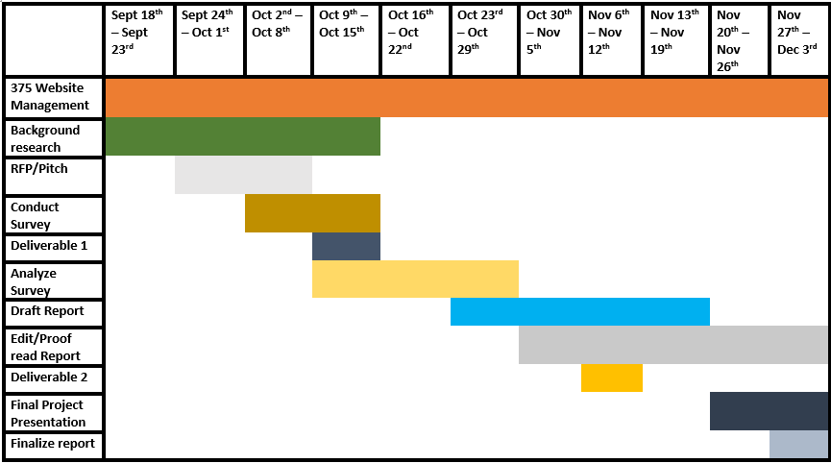

**8.0 Client team Short bio of everyone on the client team**

* **Alexandra Dawn**

UVSS Food Bank and Free Store Coordinator

alexandra.ages@gmail.com

* **Josie Simpson**

UVSS Food Bank and Free Store Assistant Coordinator

jhsimpson@outlook.com

* **Henry**

Programmer

oluthen@yahoo.com

**9.0 Glossary of terms**

* **Food bank and free store** - A food bank in the Student Union Building where a current UVic student is allowed to take a weekly ration and an unlimited amount of free stuff (donated by others).

**Basic Layout for Interview with Alexandra and Josie**

* Introduce ourselves
* What is the biggest problem with the food bank’s existing system, according to you?
* Budget? Monthly expenditure? How accurate are their current records?
* Confirm our understanding of the system with theirs
* Ask them for what they think can be done
* Explain our plan to them
* Confirm timeline and set milestones
* Any questions for us? Any suggestions?
* Thank them for their time and leave

1.your responsibility at food bank

Trainning volunteer ,budgets, tracking order, transport, managing inventory, delivery

Maintain daily running

2.when this position?

Late Aug

Last week

3.Biggest cahnllenge

tracking , managing inventory(different source and base)

Different providers some have invoice

Meeting demand

5.Budget by uvss ?

82400 $ per year

1500 per month(not sure)

6. How accurate is the record

Not so accurate

Volunteer’s work, don’t see details

Vols don’t care so much

Users might mess up paper sheets(writing on wrong column etc.)

7. How many time be distracted

Not so distracted

People might wait for long time(if vols are distracted)

Problem of Tracking sheets ?

Busy time difficult to manage, easy to skip honest policy

Had trouble reading tracking sheet

Should be more clear and readable

Donation is a challenge of recording

8. Survey of volunteers

yes (probably)

9.change shift problem, want digitized, what kind ?

Don’t know how to do. Difficult to manage shift.

Weekly schedule might work

Can be put on social media, real time notation

10. How does coffee card work(volunteer)

Don’t know, staff have their own card.

Not in budget(might be),

11.monthly update?

More often is better

12.Another interview?

Yes next week

13.Question for us

Proposal

What is ideal system?

Clearly recording input info

Paper sheet too complicated

Avoid repeated input, editable current record

//A few vols make mess, leave their personal items(inventory)